EXP 6
NITHISH RAJ L
240701366

Execution of Deluge Functions in Zoho Creator

Aim
To create and execute 10 Deluge functions in Zoho Creator for performing various operations in the Student Management System and to verify their outputs.

Procedure
- Open the Student Management System application in Zoho Creator.
- Navigate to Workflows → Functions.
- Click New Function.
- Enter the required Function Name.
- Select the appropriate Return Type.
- Add the required Arguments with their data types.
- Click Create to open the Deluge editor.
- Enter the required Deluge script.
- Click Save to save the function.
- Click Execute and provide the required input values.
- Click Submit/Execute and observe the output.
- Verify that the obtained output is correct.

Output

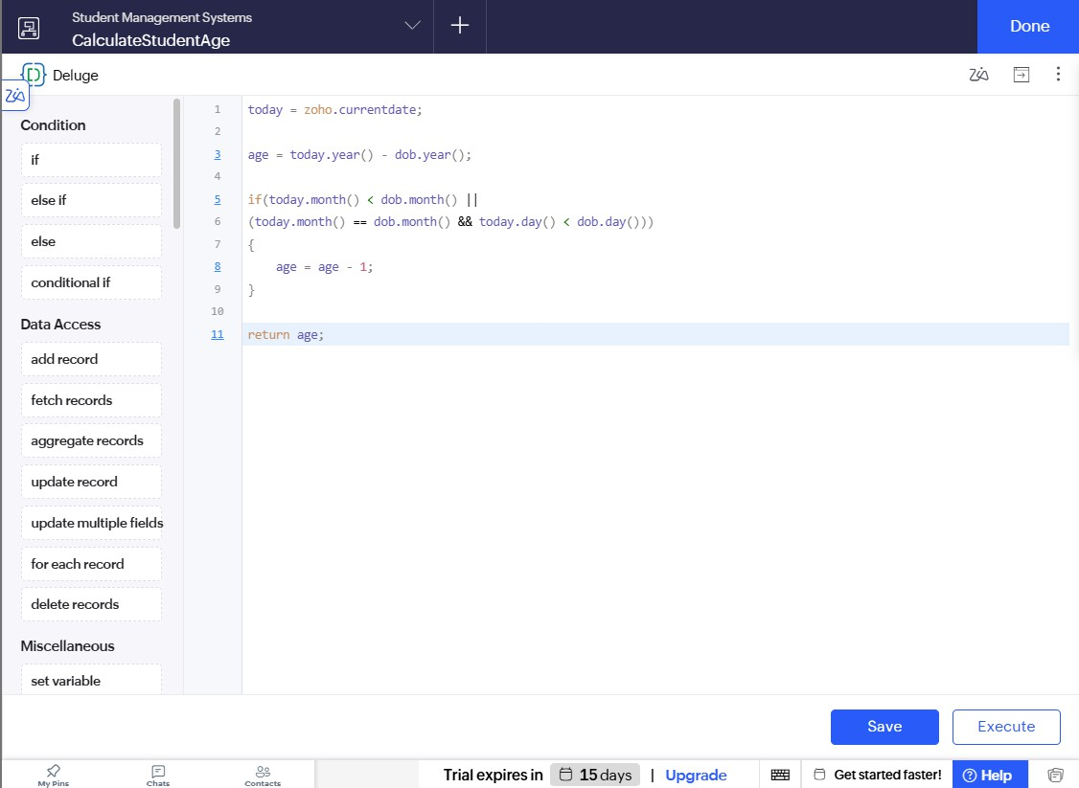
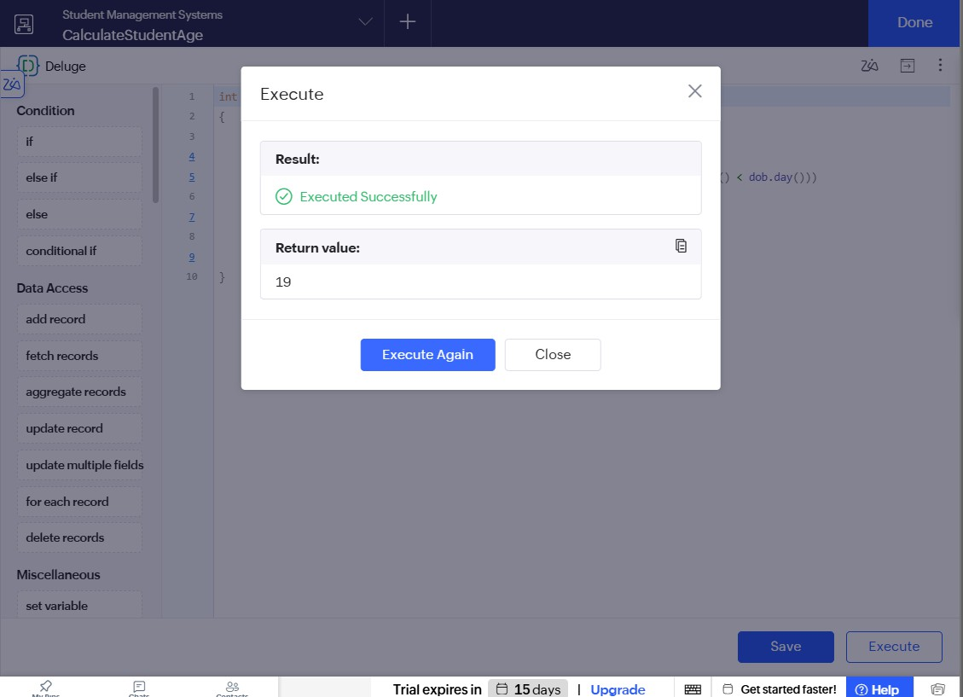

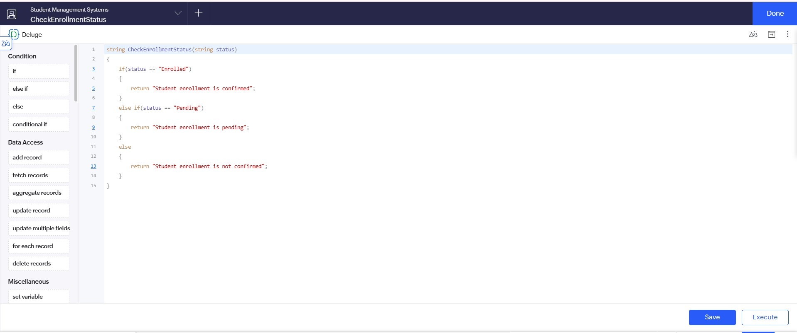
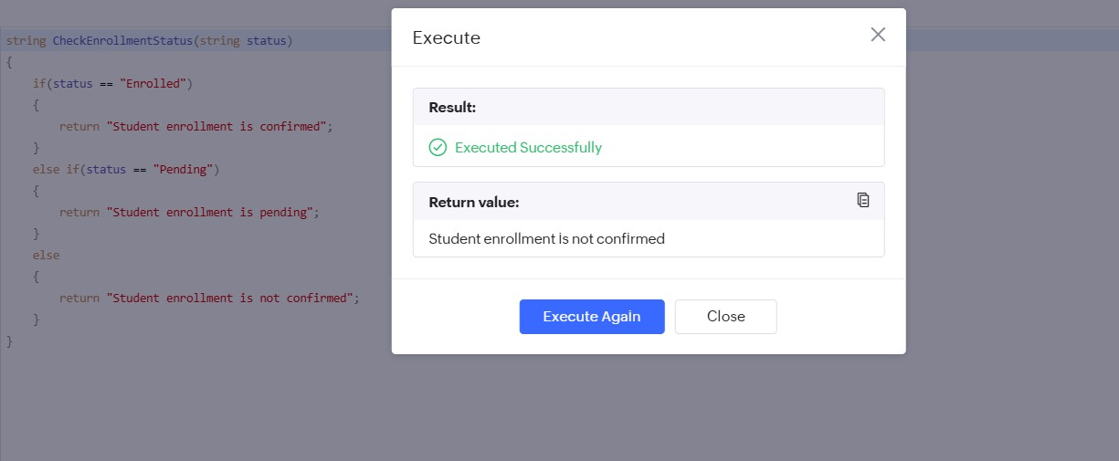

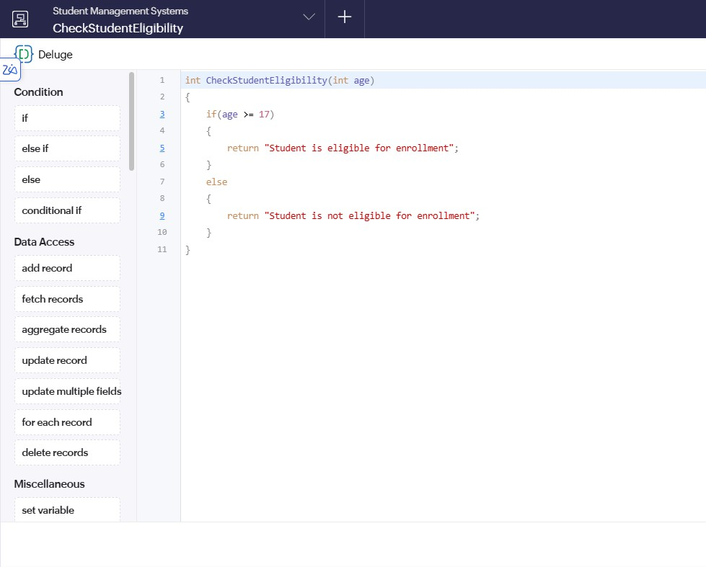
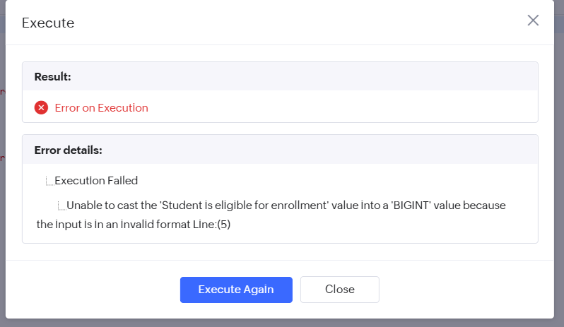

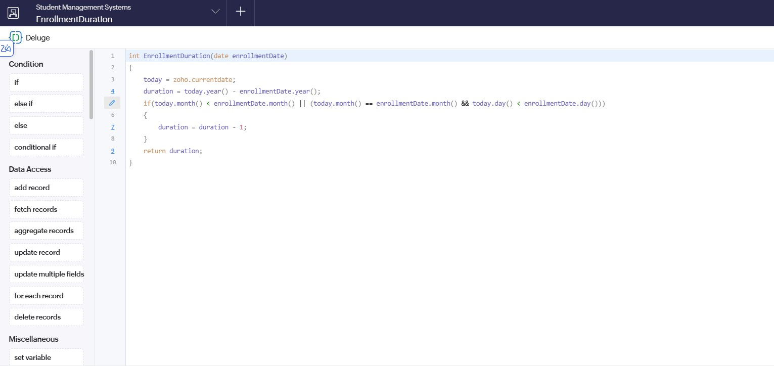
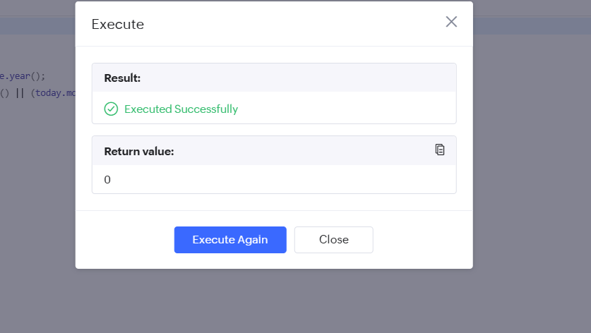

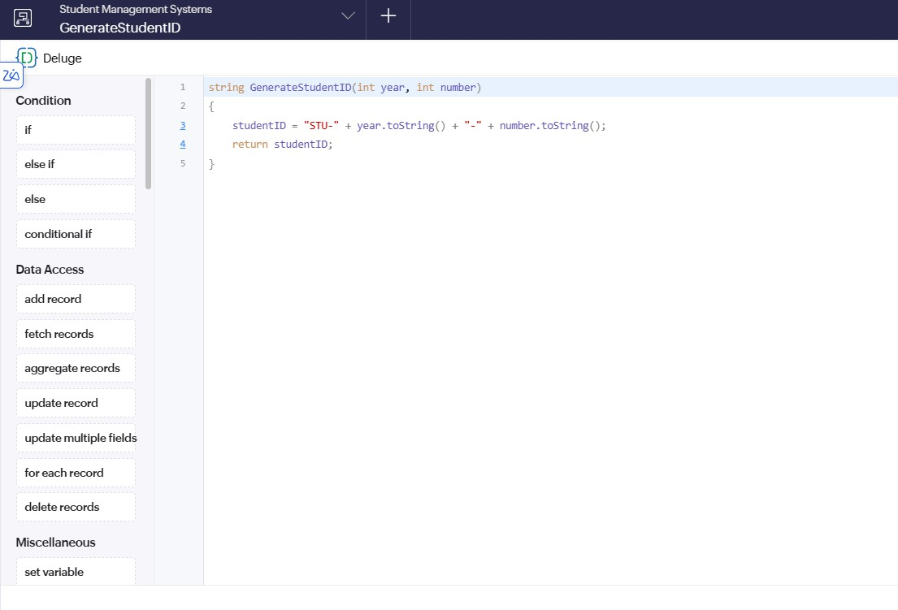
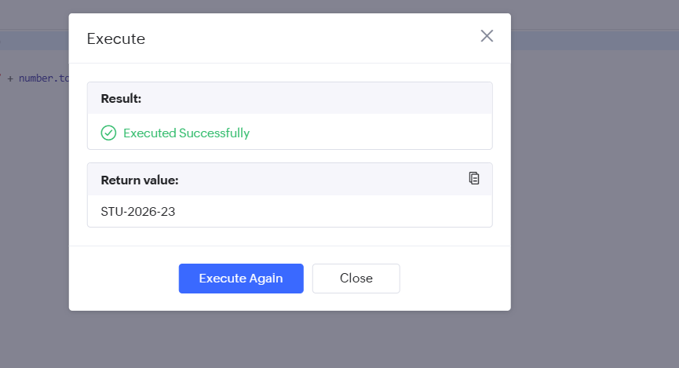

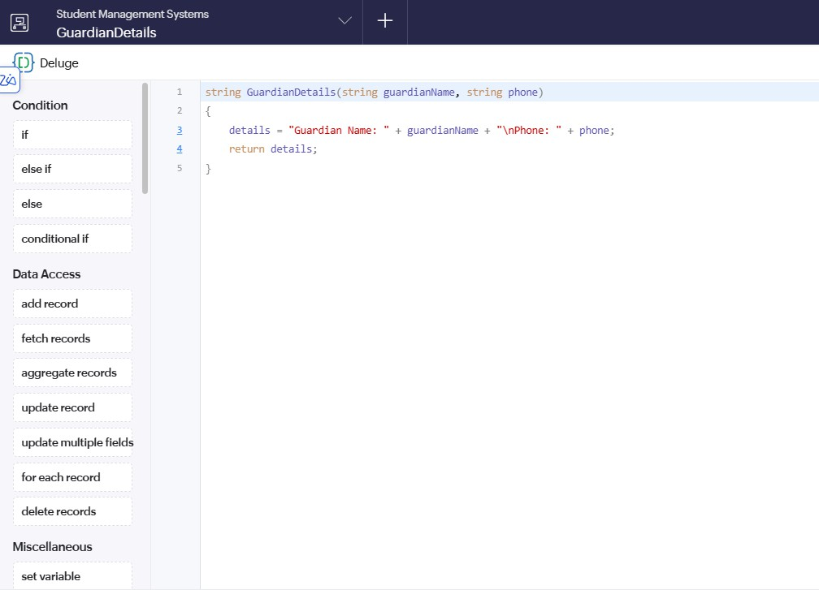
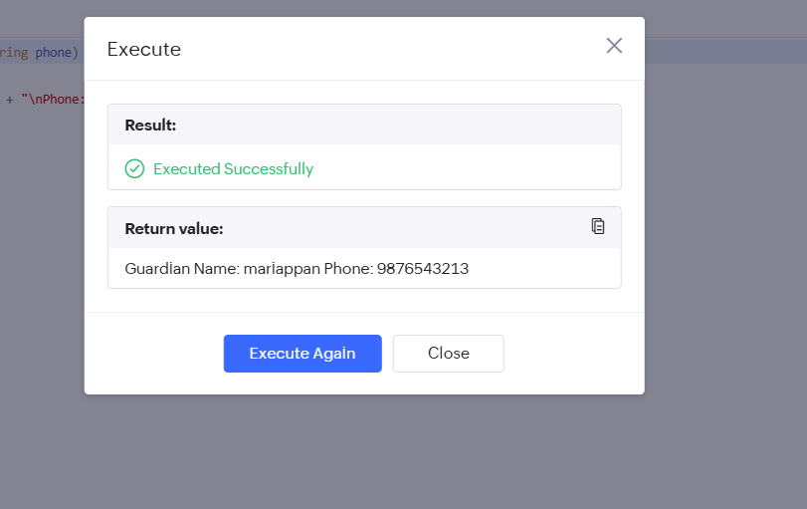

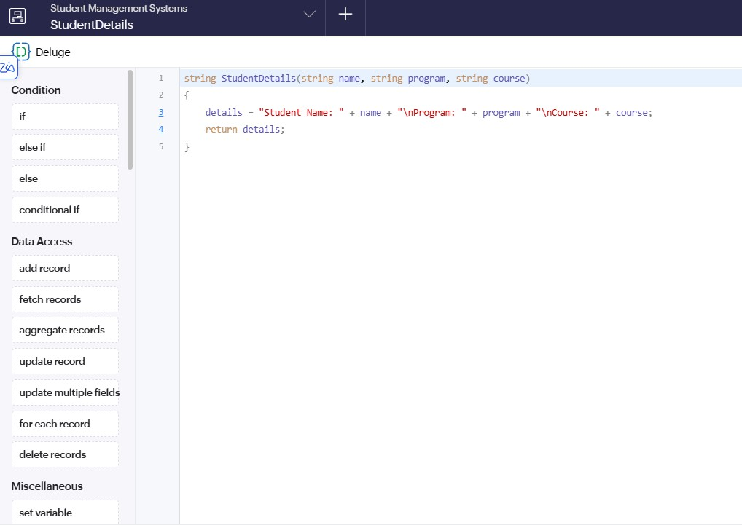
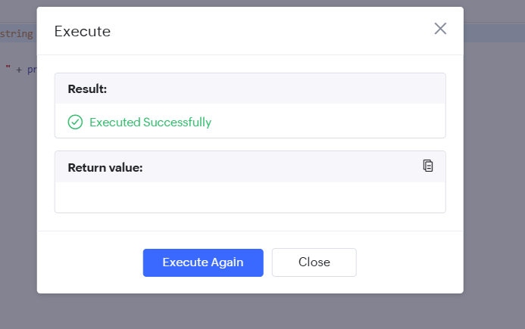
Student Name: NITHISH RAJ L Program: cse Course: cs

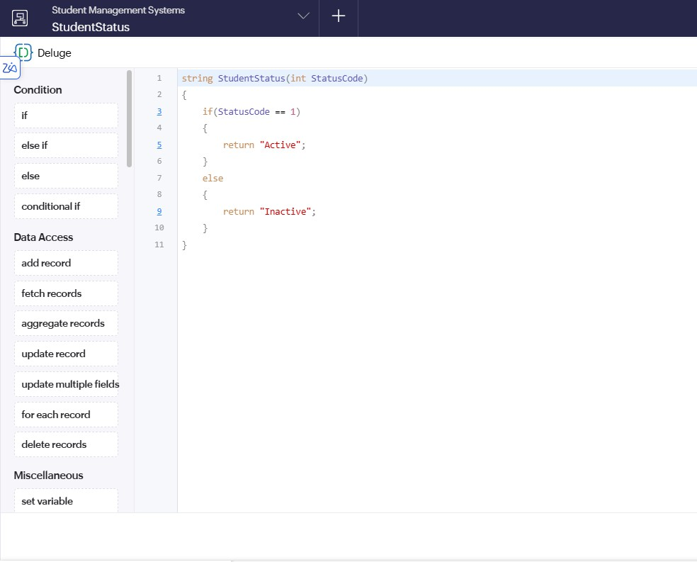
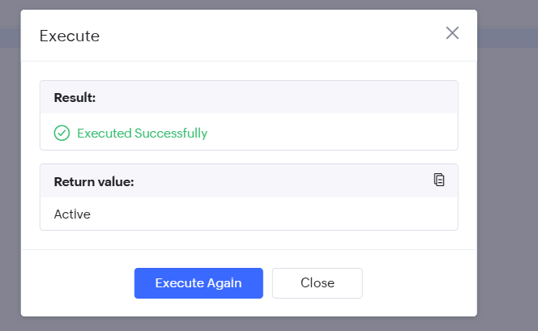

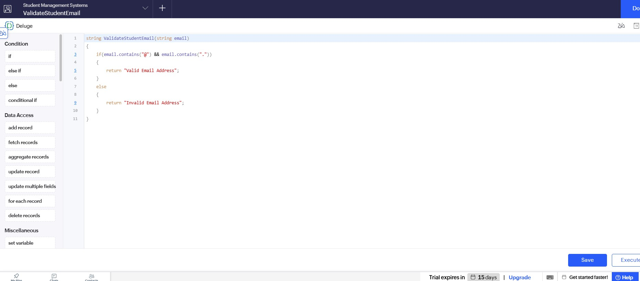
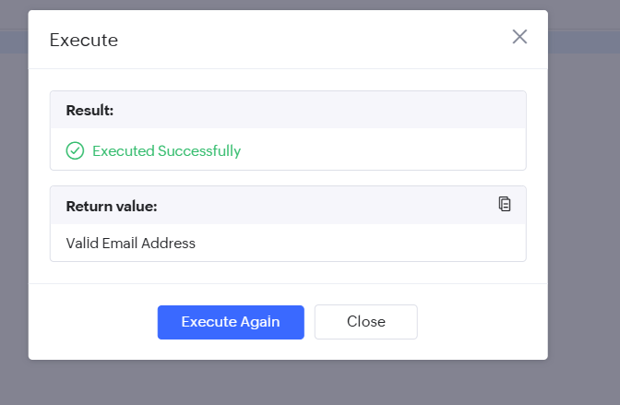

Result:

Thus, the Deluge functions were successfully created, executed, and verified in Zoho Creator .

